CODING SAMPLE

The following document is one of the coding tests that I completed. This test involves using Stata to clean, wrangle, and visualize data. The answers are my own work. Please do not distribute it without my permission. The folder can also be accessed on my GitHub at https://github.com/GGGGUKIM/Stata_codingsample4.

**2. STATA test 1.** You will write a STATA do-file/program to generate bar charts for different indicators. There are two data files, “CPSDtest_DD.dta” and “CPSDindicators.xlsx”.

1. Please reshape the dta file so that for each country, each year, there is one row for each indicator.
2. Then merge the file with CPSDindicators.xlsx by indicator name (“ind” in the excel file).
3. Drop indicators with chart type as “line”.
4. Save a new dta file with all indicators for bar charts.
5. Bar charts should display each country’s value in the latest year where data is available. Only keep the latest available data for each indicator for each country.
6. You need to produce bar charts for all indicators showing the values of these countries: United States, Canada, United Kingdom, Germany and France. Use loop/program to produce bar charts for all indicators in the new dataset. For each graph, it should have the variable name as the title, and data source as note. All the information can be found in the excel file. Graph titles, labels and source should all be generated automatically by your code. Your graph should look like this: each bar represents a country’s latest performance on the selected indicator.

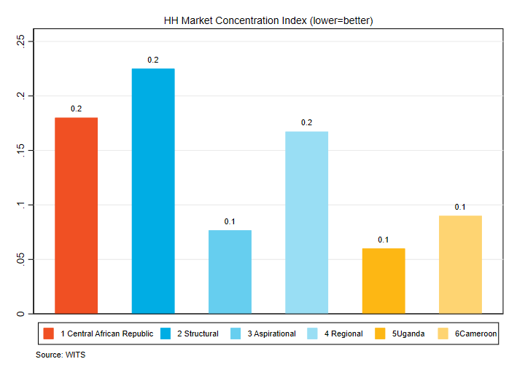

Please share your do-file and the generated graphs together with this Word document.

**3. STATA test 2.** Open “STATAtest2.dta” in the folder. Please use code to reorganize the data so that for all possible combinations of origin-destination pair, there is one row for each year during 2015-2018. Your dataset should have 5*5*4 = 100 observations. Investment value should be zero if the country pair – year combination is not included in the existing dataset.